Four guiding Ombuds principles:

Confidentiality
We maintain strict confidentiality. This makes the Ombudsperson a safe person to talk with about any concern. Speaking with the Ombudsperson about a problem does not constitute formal notice to the organization and the Ombudsperson keeps no official records.

Consulting with the Ombudsperson is a good way to develop options with the help of an impartial person. It is also a good way to learn of official policies and procedures, where to go to file a formal complaint, or how to notify others of a problem. The only exception to our confidentiality is if we learn of a risk of physical harm to anyone.

Neutrality/Impartiality
We are impartial. We do not represent individuals on either side of a conflict or problem. We do advocate for fairness throughout the event.

Informal
Our services are informal. We try to help visitors resolve issues as early as possible and at the lowest possible level.

We Do Not:
- Maintain formal written records
- Conduct formal investigations
- Play any role in formal procedures
- Provide oral or written records to anyone even if requested by a visitor

Independence
We are independent from everyone at the event. We report only to the event leader and only discuss general trends. We do not discuss individual visitors’ cases.

What is an Ombudsperson? The Ombuds provides services in three main ways:

- The Ombuds works with individuals and teams to explore and assist them in determining options to resolve conflicts as early as possible.
- The Ombuds trains and supports individuals and teams so that they can be higher performing.
- The Ombuds brings systemic concerns to the attention of the organization to enhance constant improvement.

Your Lead Ombudsperson is:

Mark Batson Baril

www.resologics.com/contact

Organization Logo Here

Ombuds Services
(Conflict Support)

Contact the Ombuds Office at
www.resologics.com/contact

- Helping individuals and teams use and wrangle conflict

- Available for everyone

- Confidential & impartial

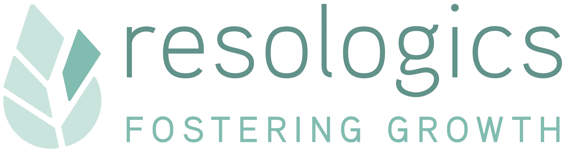
www.resologics.com

Organization Logo Here

Your Ombudsperson is a resource for everyone. The Ombuds provides informal conflict resolution and training. The Ombuds works to promote a safe and diverse atmosphere that is fair to everyone.

If you need assistance with…

- Individual or team conflicts
- Team dynamics issues
- Sluggish innovation & creativity
- Problems with managers, employees, investors, vendors, co-founders, etc…
- Health & safety concerns
- Discrimination
- Sexual harassment
- Etc…

The Ombuds is here to help!

The Ombuds can:

- Serve as a sounding board and provide an opportunity to discuss concerns openly
- Provide relevant information, including policies and procedures
- Assist in developing possible solutions
- Help in implementing the chosen course of action
- Help identify other available options and resources

Services the Ombuds can offer:

- Coaching effective ways to work with conflict
- Informal assessment of problems
- Serving as a go between to resolve problems
- Meeting facilitation
- Mediation
- Trainings and workshops to help teams be productive
- Referrals to other services

www.resologics.com

Adhering to the Code of Ethics and Standards of Practice set out by the:

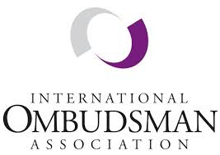

What power does your Ombudsperson have?

- Bring issues to the attention of those with the authority to address concerns
- Work with others in the organization to develop resolutions to problems
- Report systemic issues to administrators and leaders and make recommendations for resolution

The Ombuds may be able to help if you:

- Don’t know where to begin to address a problem
- Want to discuss sensitive issues confidentially
- Have tried regular channels for resolving your concern and have been unsuccessful
- Are unsure of which policies or procedures relate to your situation
- Believe policies or procedures have been applied unfairly or inappropriately

